## **Venues**

**Venue details:**

**Venue Name:**Nine Fish Art Gallery

**Description:**a large empty room with spaces for art installations on all 4 edges.

Best suited for: workshops, artist meetups, and networking events.

**Rate per hour:** 3-20 thousand rupees

**Image:**

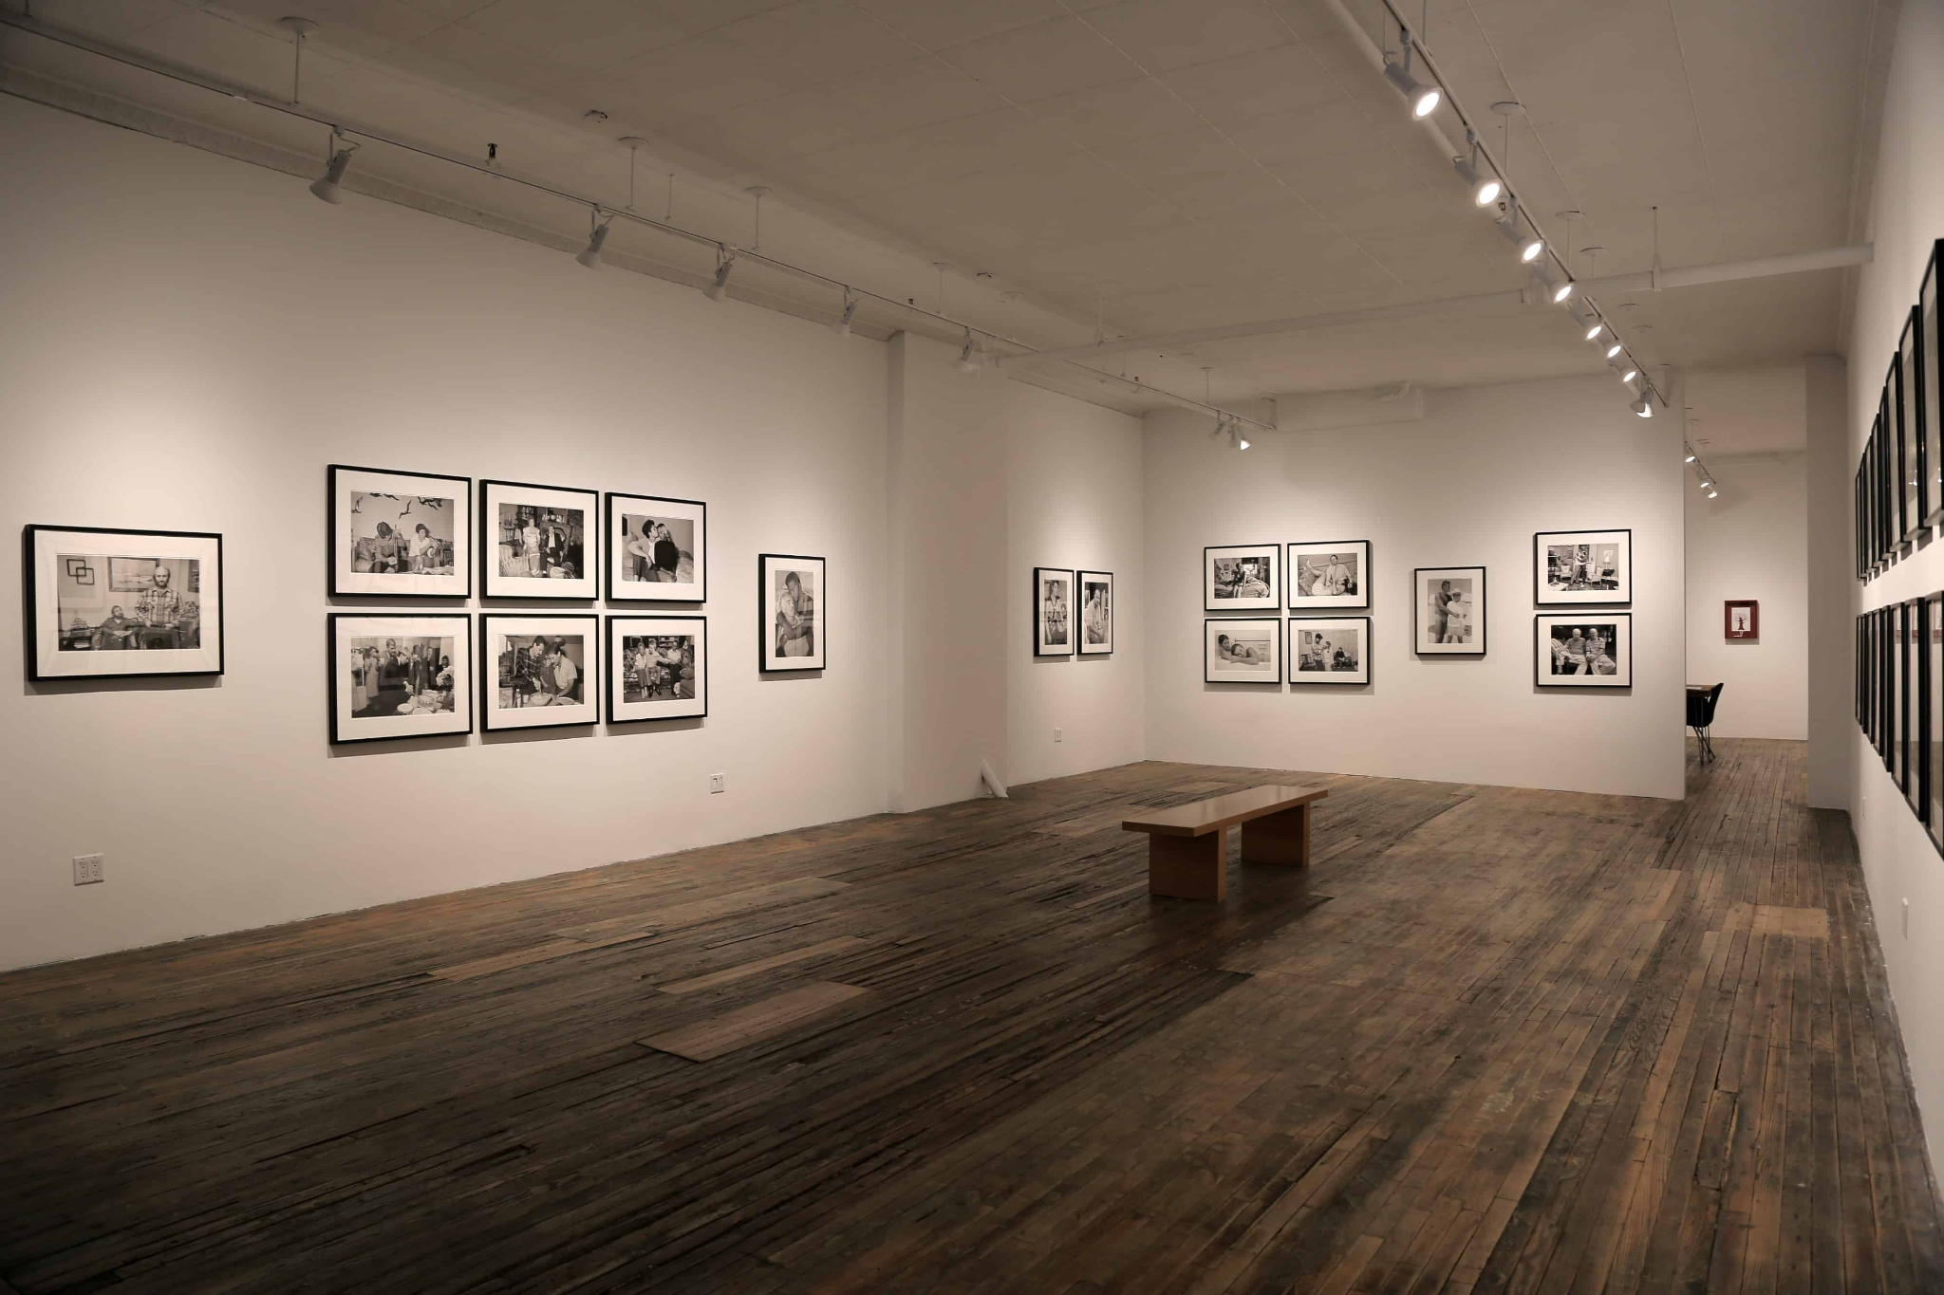

**Address:** The New Great Eastern Mills, 25-29 Dr. Ambedkar Road, Byculla, Mumbai, Maharashtra

**Venue details:**

**Venue Name**:St. Andrew's Auditorium

**Description**: an auditorium with a capacity of 300-400 people in an educational institution .Fully air conditioned,equipped with surround sound system and projector with a screen.

Best suited for: writing workshops, networking events, and presentations.

**Rate per hour:**50-80 thousand rupees

**Image:**

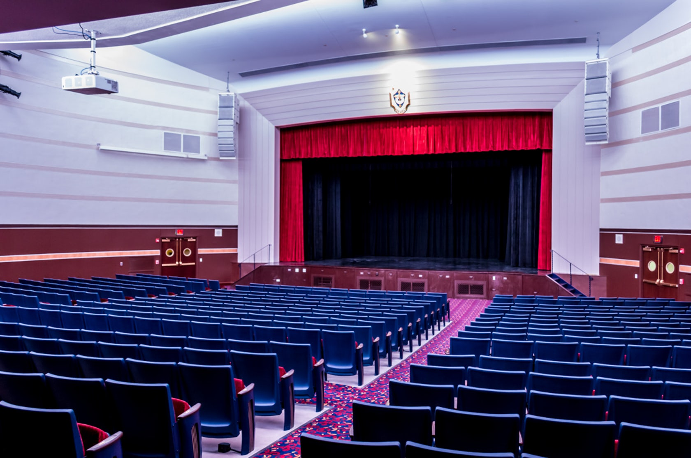

**Address: i**nside Andrew's College Premises, St Dominic Rd, St Sebastian Colony, Bandra West, Mumbai

**Venue details:**

**Venue Name**:Camp Nou Stadium

**Description:**an 80,000 sq ft ground with even grass , tracks on the boundary of ground ,goal posts on the opposite ends, with an audience capacity of 4k-5k.

Best suited for: sports events, concerts, comedy shows, theater productions, and presentations.

**Rate per hour:3-5 lakh rupees**

**Image:**

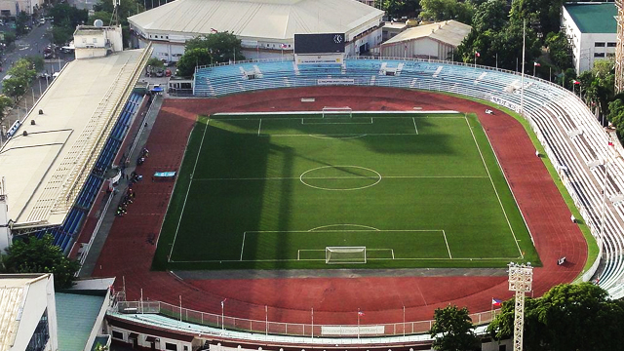

**Address:** Dinshaw Vacha Road, Churchgate, Mumbai

**Venue details:**

**Venue Name:** RadissonHotel

**Description:**a hotel equipped with restaurants, bars, ballrooms, conference rooms,party halls ,single and double rooms,with catering services.

Best suited for: parties, dinner parties, tasting events, business meetings, conferences, presentations, networking events, and wedding receptions.

**Rate per hour:**2-8 lakh rupees

**Image:**

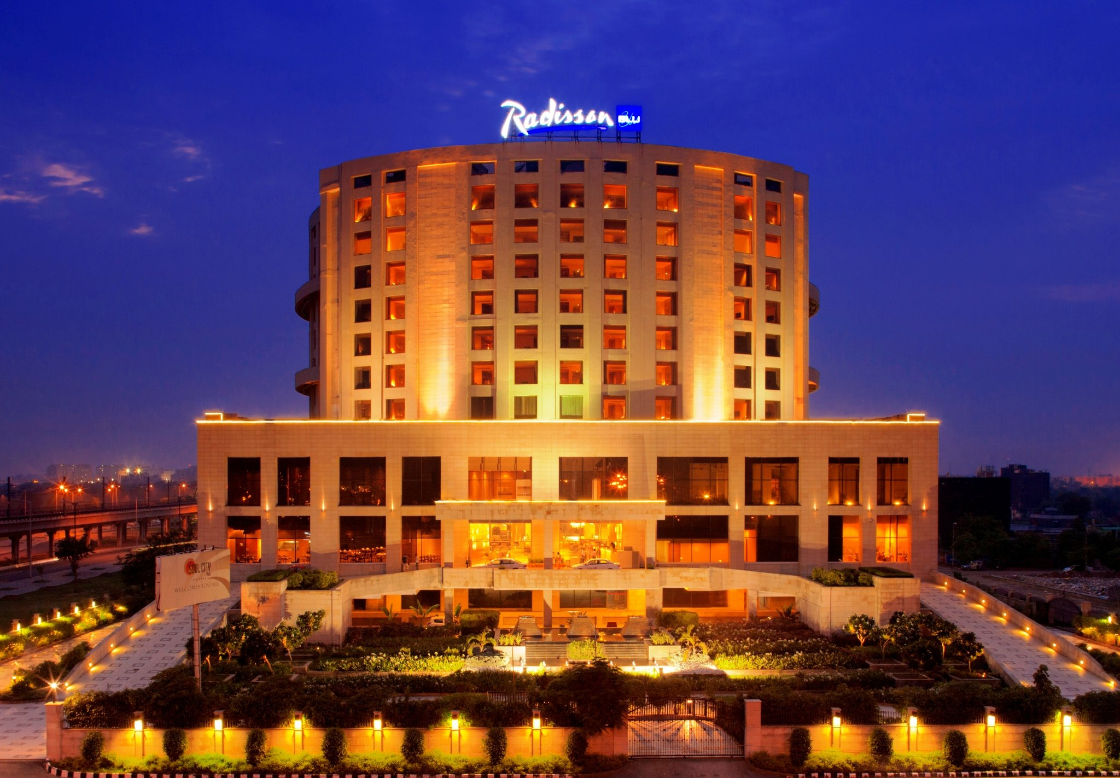

**Address:** 114 Dr. E. Moses Road, Worli, Mumbai, Maharashtra